Research Strategy Default Backtest Report
Strategy / EA: HA V1.0
Expert: HA V1.0.ex5 | Symbol: XAUUSD Dukascopy | Timeframe: M15
Backtest Period: 2013.01.01 -> 2026.07.03 | Initial Deposit: $2,500.00
Generated: 2026-09-23 08:05:46 UTC
This report documents the DEFAULT (un-optimised baseline) backtest for this researched strategy. It establishes baseline performance and trade mechanics directly from the EA's core MQL5 implementation prior to running genetic parameter optimization and robustness stress-tests.

Key Performance Metrics
Metric | Value
Net Profit ($) | 20,901.1400
Net Profit (%) | 836.0456
Profit Factor | 1.1700
Sharpe Ratio | 0.4100
Max Balance Drawdown (%) | 20.1500
Recovery Factor | 2.1100
Win Rate (%) | 40.2800
Total Trades | 1363
Largest Profit Trade ($) | 3,973.5500
Largest Loss Trade ($) | -1,975.8000

Equity & Performance Charts
Chart Equity Growth
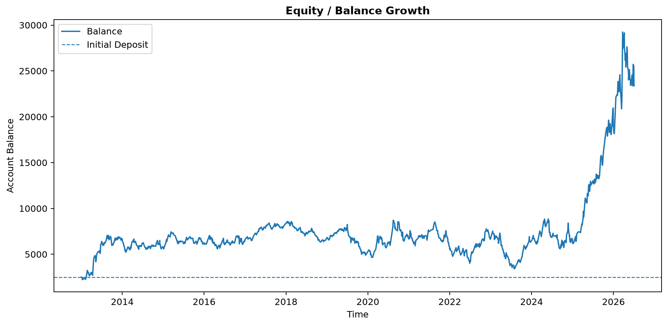

Chart Percent Gain
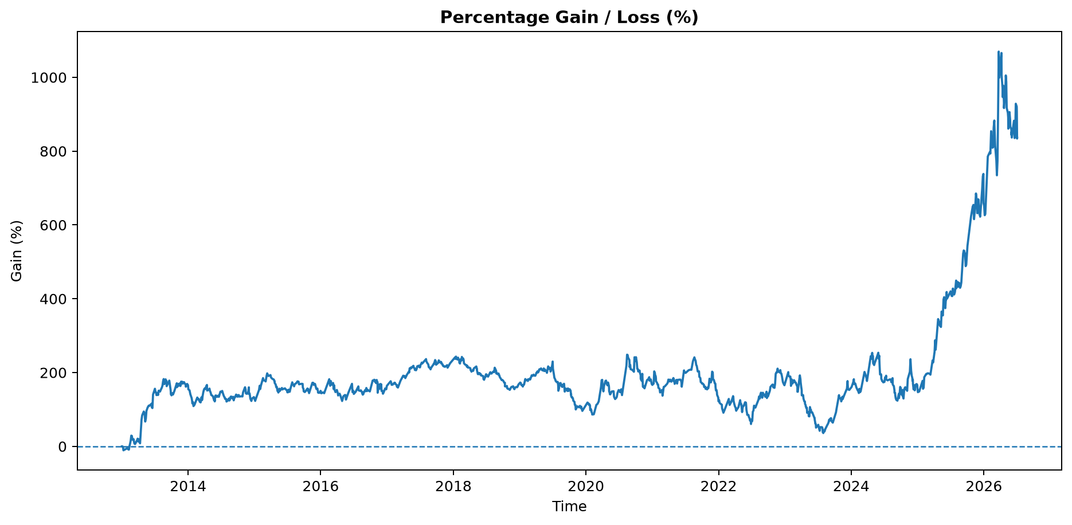

Chart Profit Dollars
